Mid
Lecture 1
1. Define Operating System with example.
Ans: An operating system (OS) is a software that manages a computer's hardware and software resources, acting as an intermediary between the user and the computer's hardware. Example- Microsoft Windows, Apple's macOS, and Linux.
2. Explain Computer System Structure.
Ans: Computer system can be divided into four components:
• Hardware – provides basic computing resources- CPU, memory, I/O devices
• Operating system - Controls and coordinates use of hardware among various applications and users.
• Application programs – Word processors, compilers, web browsers, database systems, video games
• Users- People, machines, other computers.
3. Four Component of a Computer System.
Ans: page 4.
4. i. Define Bootstrap program.
Ans: The initial program that runs when a computer is powered up or rebooted.
→It is stored in the ROM
→It must locate and load into memory the OS Kernel.

ii. Define Interrupt.
Ans: Interrupt is a signal that tells the CPU something important has happened and it needs to stop what it's doing and pay attention.

iii. Define System Call/Monitor Call.
Ans: Software may trigger an interrupt by executing a special operation called System Call.

5. Operating System goals/Objectives.
Ans: • Make the computer system convenient to user
• Use the computer hardware in an efficient manner

6. Function/Characteristics of Operating System.
Ans: •Process Management: Create, schedule (start/paus/terminate), run, sync, communicate, and end processes.
•Memory Management: Track, allocate, free, and protect memory.
•I/O Device Management: Control devices, manage data flow, handle errors, and allocate devices.
•File Management: Create, organize, access, protect, and back up files.
•Virtual Memory: Extend RAM to run large programs using paging and swapping.
•Security: Protect data and resources with authentication, authorization, and encryption.

Lecture 2
7. Types of Operating System and explain any three types of OP.
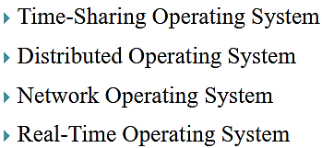
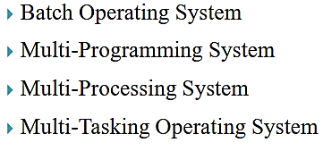
Ans:

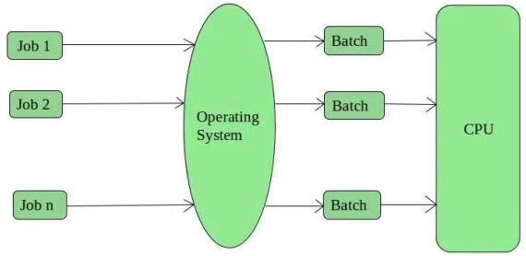
i. Batch Operating System:
Here the operator takes similar jobs having the same
requirements and groups them into batches. Batch Operating
System is designed to manage and execute a large number of
jobs efficiently by processing them in groups.

ii. Multi-Processing Operating System:
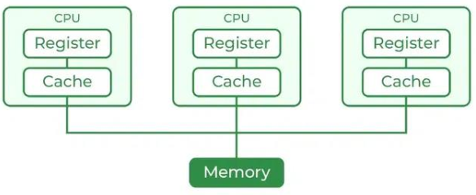
Multi-Processing Operating System is a type of Operating System
in which more than one CPU is used for the execution of resources.
It betters the throughput of the System.

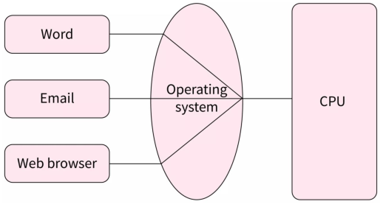
iii. Multi-Tasking / Time Sharing Operating System:
Multitasking Operating System is simply a multiprogramming Operating
System with having facility of a Round-Robin Scheduling Algorithm. It can run
multiple programs simultaneously.

8. Define Uniprocessor.
Ans: Uniprocessor is a computer system type that has only one central processing unit which means that only one instruction will be executed at a time.

